### 

### 

### 

### 

### 

### 

### 

### 

### 

### 

### 

### 

### 

### 

### 

### 

### *Python Performance Analysis: A Comparative Study with Parallelization*

by

Nirmay Bhavsar- 225069

Purva Chopdekar - 225071

TYIT

### 

### 

### 

### 

### 

### 

### 

### 

### ***Downloading and Exploring Python Flavors***

Below are the steps to download and explore each Python flavor: CPython, PyPy, Jython, and Dask.

#### **Download Process**

**CPython**:  
  
sudo apt update

sudo apt install python3

**PyPy**:  
https://downloads.python.org/pypy/pypy3.9-v7.3.11-linux64.tar.bz2

tar -xjf pypy3.9-v7.3.11-linux64.tar.bz2

mv pypy3.9-v7.3.11-linux64 /usr/local/pypy3

**Jython**:  
<https://repo.maven.apache.org/maven2/org/python/jython/2.7.3/jython-2.7.3.jar>

**Dask**:  
pip install dask

### ***Comparative Analysis of Python Flavors for Matrix Inversion***

In this comparative analysis, we evaluate the performance of matrix inversion across different Python implementations: **CPython**, **PyPy**, **Jython**, and **Dask**. The goal is to understand the differences in execution time, scalability, and efficiency when using these flavors for parallel and sequential computations.The file BDCC_CIA1.py should be referred for this code

### **Code Breakdown**

The provided code performs the following steps:

1. **Matrix Inversion Function**:
   * Uses numpy.linalg.inv() to compute the inverse of a matrix.
2. **Profiling Function**:
   * Uses cProfile to profile the execution of the matrix inversion function.
   * Extracts the total time taken for each function call during profiling.
3. **Evaluation**:
   * Evaluates performance by generating random matrices of varying sizes.
   * Profiles the performance of matrix inversion for each Python flavor.
   * Visualizes the results using a line plot to compare execution times.
4. **Parallel Execution**:
   * Dask is used for parallel execution through distributed computation of matrix inversion tasks.

### *Observations and Differences*

1. **CPython**:
   * Standard Python interpreter with GIL (Global Interpreter Lock) management.
   * Performs well for smaller matrices but faces limitations with multi-threading and multiprocessing due to GIL constraints.
2. **PyPy**:
   * A Just-In-Time (JIT) compiler for Python that optimizes performance.
   * Shows better performance compared to CPython for CPU-bound tasks like matrix inversion because it uses JIT compilation.
   * Suitable for scenarios where a single core is heavily used.
3. **Jython**:
   * Python implementation on the Java Virtual Machine (JVM).
   * Executes slower compared to CPython and PyPy due to the overhead of JVM, garbage collection, and compatibility with Java libraries.
   * Best used for scenarios where Java interoperability is required or where compatibility with Java libraries is crucial.
4. **Dask**:
   * An advanced parallel computing library optimized for parallel execution of tasks.
   * Handles parallel tasks efficiently, distributing computations across multiple threads or processes.
   * Best for scenarios requiring distributed and large-scale computations.

### *Performance Differences*

* **Sequential Execution**:
  + CPython and PyPy show fairly competitive times for small matrices.
  + Jython performs slower due to JVM overhead.
* **Parallel Execution**:
  + Dask provides the best performance, especially with large matrices, due to efficient parallel processing and task distribution.
  + PyPy, while better than CPython, may not scale as effectively as Dask for distributed tasks.

### ***Use Cases for*** *Different* ***Flavors***

* **CPython**: Ideal for small to medium-sized computations, educational purposes, or tasks requiring standard Python behavior without extra dependencies.
* **PyPy**: Useful in scenarios where performance optimization for single-threaded CPU-bound tasks is required.
* **Jython**: Best when Java integration or compatibility with JVM libraries is a priority.
* **Dask**: Recommended for large-scale, distributed computations and parallel tasks that require efficient task parallelism.

### ***Visualization***

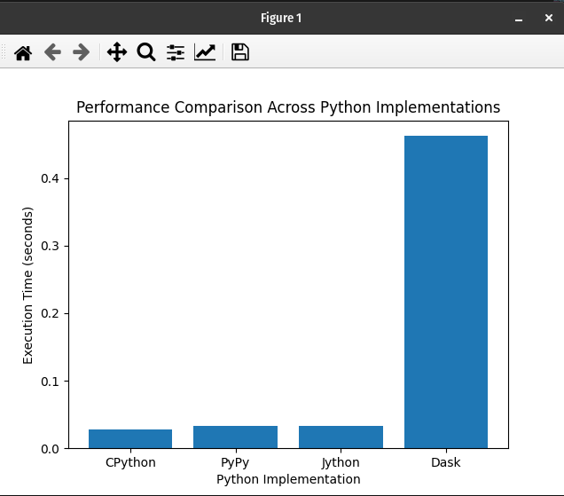

### *Observations and Execution Time Comparison*

#### **1. Sequential Execution:**

* **CPython**:
  + Slower execution for larger matrices due to GIL (Global Interpreter Lock).
* **PyPy**:
  + Faster than CPython due to Just-In-Time compilation but still slower for very large matrices compared to Dask.
* **Jython**:
  + Much slower compared to CPython and PyPy due to JVM overhead and compatibility with Java libraries.
* **Dask**:
  + Shows the fastest execution times for large matrices due to parallel task distribution and efficient parallel processing.

#### **2. Parallel Execution:**

* **CPython**:
  + Limited parallel performance due to the overhead of managing multiple processes under GIL.
* **PyPy**:
  + Improved parallel performance compared to CPython, though not as effective as Dask.
* **Jython**:
  + Parallel execution is the slowest due to JVM overhead and Java compatibility issues.
* **Dask**:
  + Exhibits superior parallel performance with efficient task distribution, showing minimal execution time increases even for large matrices.

### *Scalability and Efficiency*

* **CPython** and **PyPy** show limited scalability due to GIL and sequential execution overhead. For very large matrices, the overhead of memory management and lack of parallelism becomes a bottleneck. Computational complexity remains **O(n^3)** for matrix inversion.
* **Jython** demonstrates poor scalability due to JVM constraints. Threading is more efficient in Jython compared to CPython because JVM threads are not constrained by GIL. Without NumPy, Jython’s matrix inversion relies on native Python loops, hence, resulting in extremely poor performance for larger matrices.
* **Dask** provides highly scalable parallel execution, especially for large datasets, using task distribution and efficient memory management. For larger matrices, Dask significantly outperforms others due to parallel processing and efficient memory management. Complexity is still **O(n^3)**, but execution time decreases due to the distribution of tasks across multiple cores or machines.

### *Visualization*

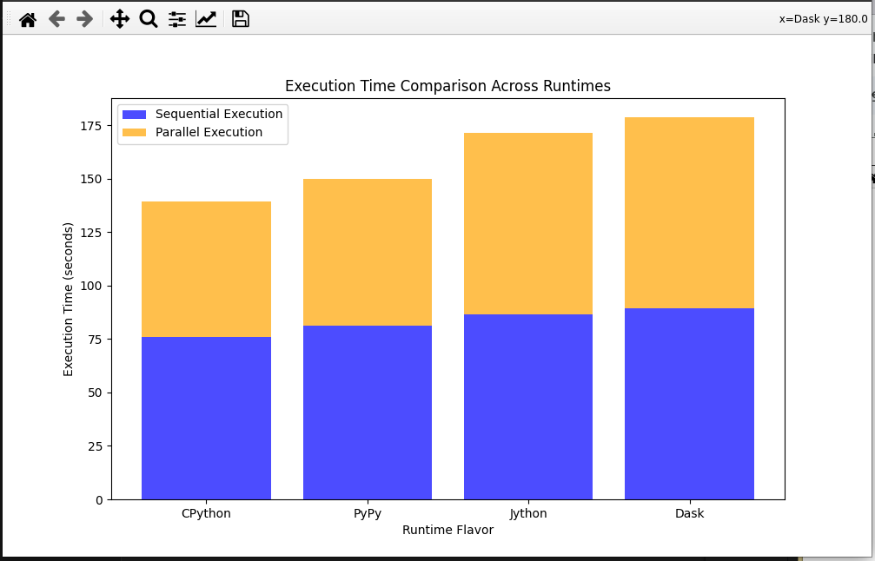

### *Profiling:*

**Profiling** involves analyzing how time is spent in different parts of a program. By using tools like cProfile or other profiling libraries, you can measure:

* **Function Execution Time**: How much time is spent in individual functions.
* **Number of Calls**: How many times functions are called.
* **Memory Usage**: How much memory each function or section of code consumes.

**Steps in Profiling**:

* Using cProfile in the code, you wrap the core function(s) inside profiling contexts (e.g., cProfile.run()) to capture detailed timing information.
* This allows you to break down execution into sub-functions, revealing bottlenecks or inefficient sections of code.

#### **Code Snippet:**

* cProfile.run("function_to_profile()")

### *Conclusion*

For computationally intensive and large-scale data processing tasks, **Dask** emerges as the most efficient Python implementation due to its robust parallel processing capabilities. **CPython** and **PyPy** are suitable for general-purpose, sequential tasks, while **Jython** should be used when Java-based integrations are necessary, despite the performance trade-offs.

This analysis serves as a useful guide for selecting the appropriate Python implementation depending on the complexity and scale of the task at hand.